Student Lab Manual
Full-Stack Deployment Inside an Ubuntu Docker Container
Install Git, .NET SDK/Runtime, Node.js, Angular CLI, Nginx; pull source code from GitHub; deploy ASP.NET Core API and Angular app
Lab Duration: 3 to 5 hours
Target Audience: Beginners learning Linux containers, application deployment, Nginx hosting, and full-stack deployment basics.
Platform Assumption: Docker Desktop running on Windows. Commands are written for Windows PowerShell or Command Prompt on the host, and Bash inside the Ubuntu container.
Cover / Completion Screenshot Placeholder
Paste screenshot here

Lab Overview
In this lab, students will use an Ubuntu Linux Docker container like a small Linux server. Inside the container, they will install required tools, clone two GitHub repositories, run a .NET backend API, build an Angular frontend, and serve the Angular app through Nginx. Nginx will also reverse proxy API calls to the .NET application.
The Angular application will be accessible from the local system browser using http://localhost:8080. The backend API will run inside the same container and will be reached through Nginx using /api routes.
Host Machine / Browser
|
| http://localhost:8080
v
Docker Port Mapping: 8080 -> 80
|
v
Ubuntu Container
|
+-- Nginx on port 80
| +-- Serves Angular static files from /var/www/html/angular
| +-- Reverse proxies /api to ASP.NET Core API
|
+-- ASP.NET Core API running on http://localhost:5000
|
+-- Git, .NET SDK, Node.js, npm, Angular CLI installed
Placeholder | Value to Fill
Backend API GitHub Repository URL | https://github.com/114-Vaibhav/demo-dotnet-api
Angular GitHub Repository URL | https://github.com/114-Vaibhav/demo-angular-app
Backend project folder name after git clone | Demo-dotnet-api
Angular project folder name after git clone | Demo-angular-app
Backend project .csproj file name | DemoApi.csproj
Angular build output folder under dist | Demo-angular-app

Important Notes for Students
- This lab intentionally installs software manually inside the Ubuntu container. This is useful for learning Linux server administration inside containers.
- For production, we normally write a Dockerfile instead of manually installing tools and committing containers.
- Do not close the terminal running the container unless instructed.
- If a command asks for confirmation, use -y where shown or type y and press Enter.
- Replace placeholder values like <DOTNET_API_REPO_URL> and <ANGULAR_REPO_URL> with your actual GitHub repository URLs.

Step 1: Pull Ubuntu Linux Image
Objective: Download the Ubuntu Linux image to your local Docker environment.
Commands:
docker pull ubuntu:24.04
docker images
Command Explanation:
- docker pull downloads an image from Docker Hub.
- ubuntu:24.04 means Ubuntu version 24.04.
- docker images lists all images available locally.
Expected Output / Result:
You should see ubuntu with tag 24.04 in the image list.
Verification:
Confirm that the ubuntu:24.04 image appears in the output of docker images.
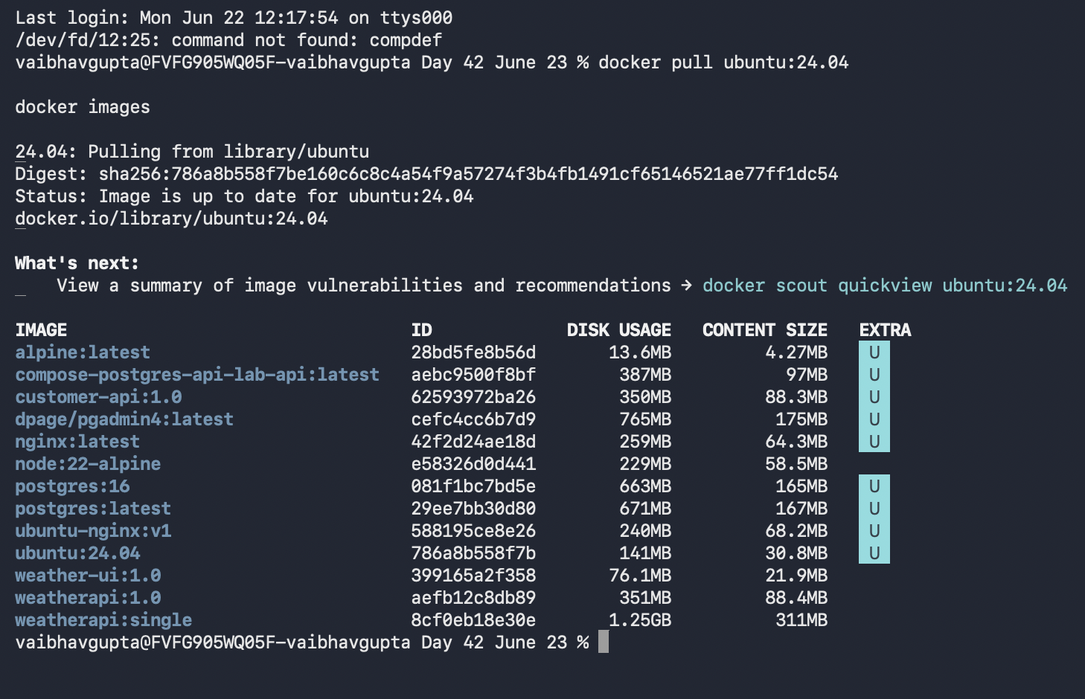
Student Notes: Ubuntu image is up to date.

Step 2: Start Ubuntu Container with Port Mapping
Objective: Create an Ubuntu container and expose ports so the host browser can access the app later.
Commands:
docker run -it --name fullstack-ubuntu -p 8080:80 -p 5000:5000 ubuntu:24.04 bash
Command Explanation:
- -it starts the container in interactive mode.
- --name fullstack-ubuntu assigns a readable container name.
- -p 8080:80 maps host port 8080 to container port 80 for Nginx.
- -p 5000:5000 maps host port 5000 to container port 5000 for direct API testing.
- bash opens a Linux shell inside the container.
Expected Output / Result:
You should see a Linux prompt similar to root@container-id:/#.
Verification:
Run pwd and whoami. Expected current user is root.
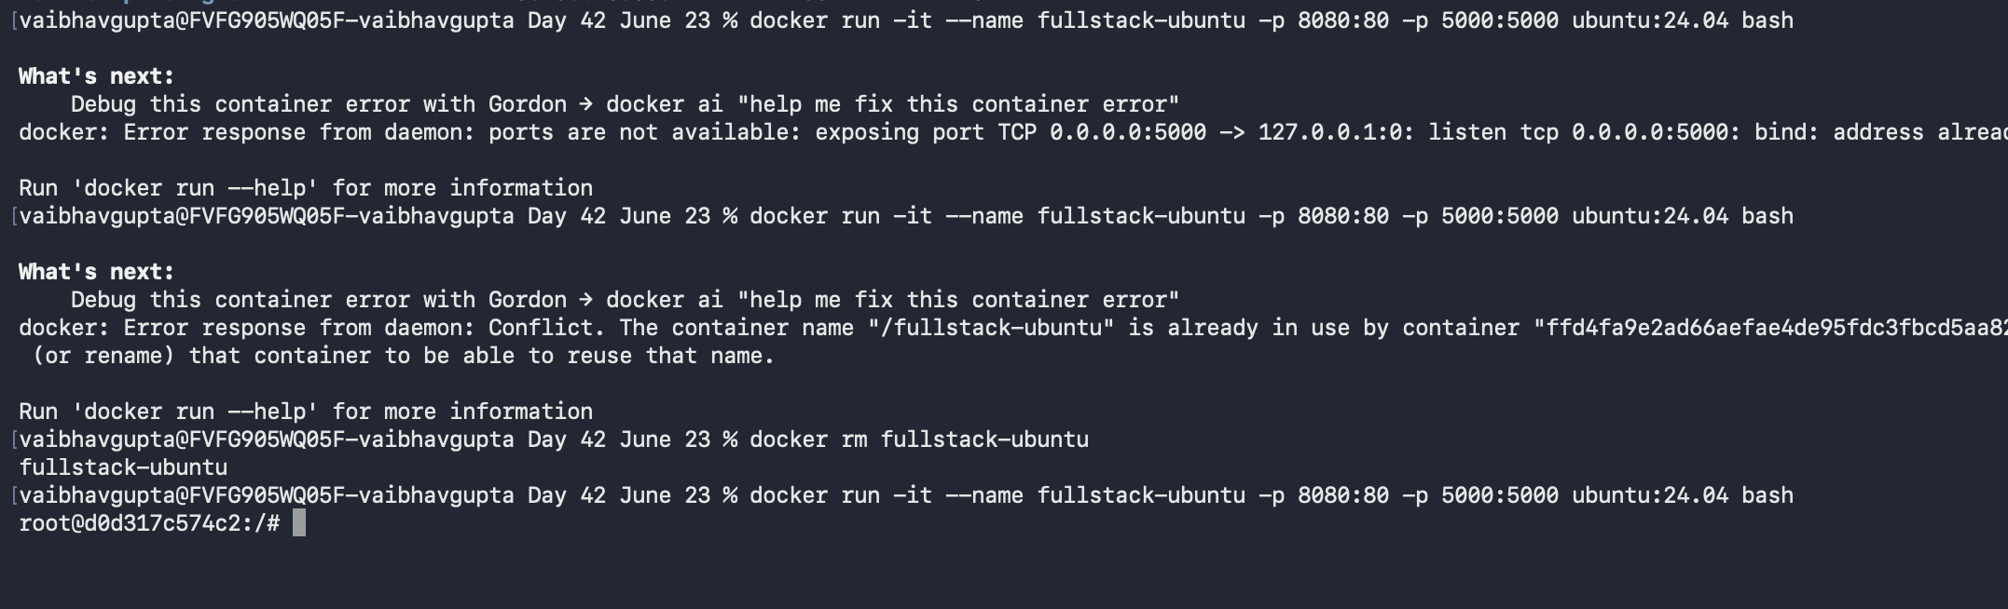
Student Notes: In mac port 5000, used by AirPlay so need to turn off.

Step 3: Update Ubuntu Package Repository
Objective: Refresh package information before installing software.
Commands:
apt update
Command Explanation:
- apt is Ubuntu package manager.
- apt update downloads the latest package index.
- This does not install software; it updates package metadata.
Expected Output / Result:
Expected output includes Reading package lists... Done.
Verification:
No error should appear at the end of the command.
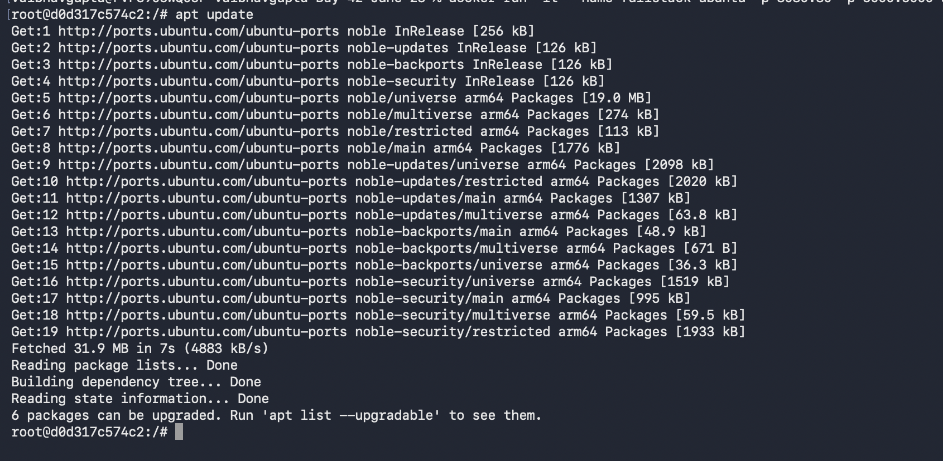
Student Notes: working fine, everything updated

Step 4: Install Basic Utilities and Git
Objective: Install tools required for downloading packages and cloning GitHub repositories.
Commands:
apt install -y git curl wget nano ca-certificates gnupg lsb-release software-properties-common
Command Explanation:
- git is used to clone source code from GitHub.
- curl and wget are used to download files from the internet.
- nano is a beginner-friendly terminal editor.
- ca-certificates and gnupg help with secure package repositories.
- -y automatically confirms installation.
Expected Output / Result:
Packages should be installed without errors.
Verification:
Run git --version and curl --version.
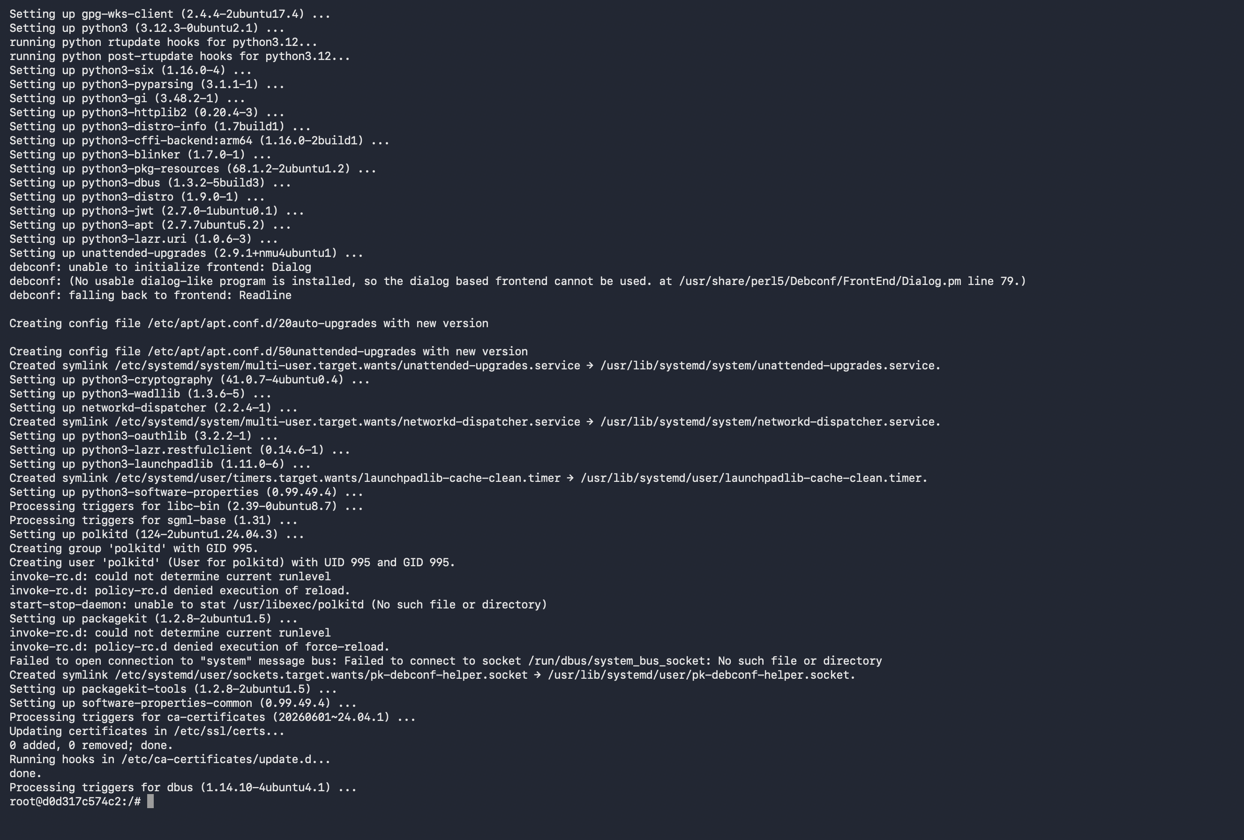
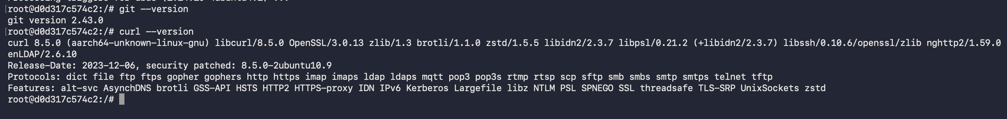
Student Notes: Installed successfully, asked for region and timezone.

Step 5: Verify Git Installation
Objective: Confirm Git is available inside the Ubuntu container.
Commands:
git --version
Command Explanation:
- git --version displays the installed Git version.
- This proves the container can use Git commands.
Expected Output / Result:
Expected output: git version x.xx.x
Verification:
Paste the git version screenshot.

Student Notes: git installed

Step 6: Install .NET 8 SDK and Runtime
Objective: Install .NET SDK so you can restore, build, publish, and run the ASP.NET Core application.
Commands:
wget https://packages.microsoft.com/config/ubuntu/24.04/packages-microsoft-prod.deb -O packages-microsoft-prod.deb
dpkg -i packages-microsoft-prod.deb
apt update
apt install -y dotnet-sdk-8.0 aspnetcore-runtime-8.0
Command Explanation:
- The Microsoft package file adds Microsoft package sources to Ubuntu.
- dpkg -i installs the package source configuration.
- apt update refreshes packages again after adding Microsoft sources.
- dotnet-sdk-8.0 installs build tools and runtime.
- aspnetcore-runtime-8.0 installs the ASP.NET Core runtime used to run Web APIs.
Expected Output / Result:
.NET SDK and ASP.NET Core runtime should install successfully.
Verification:
Run dotnet --info to verify SDK and runtime details.
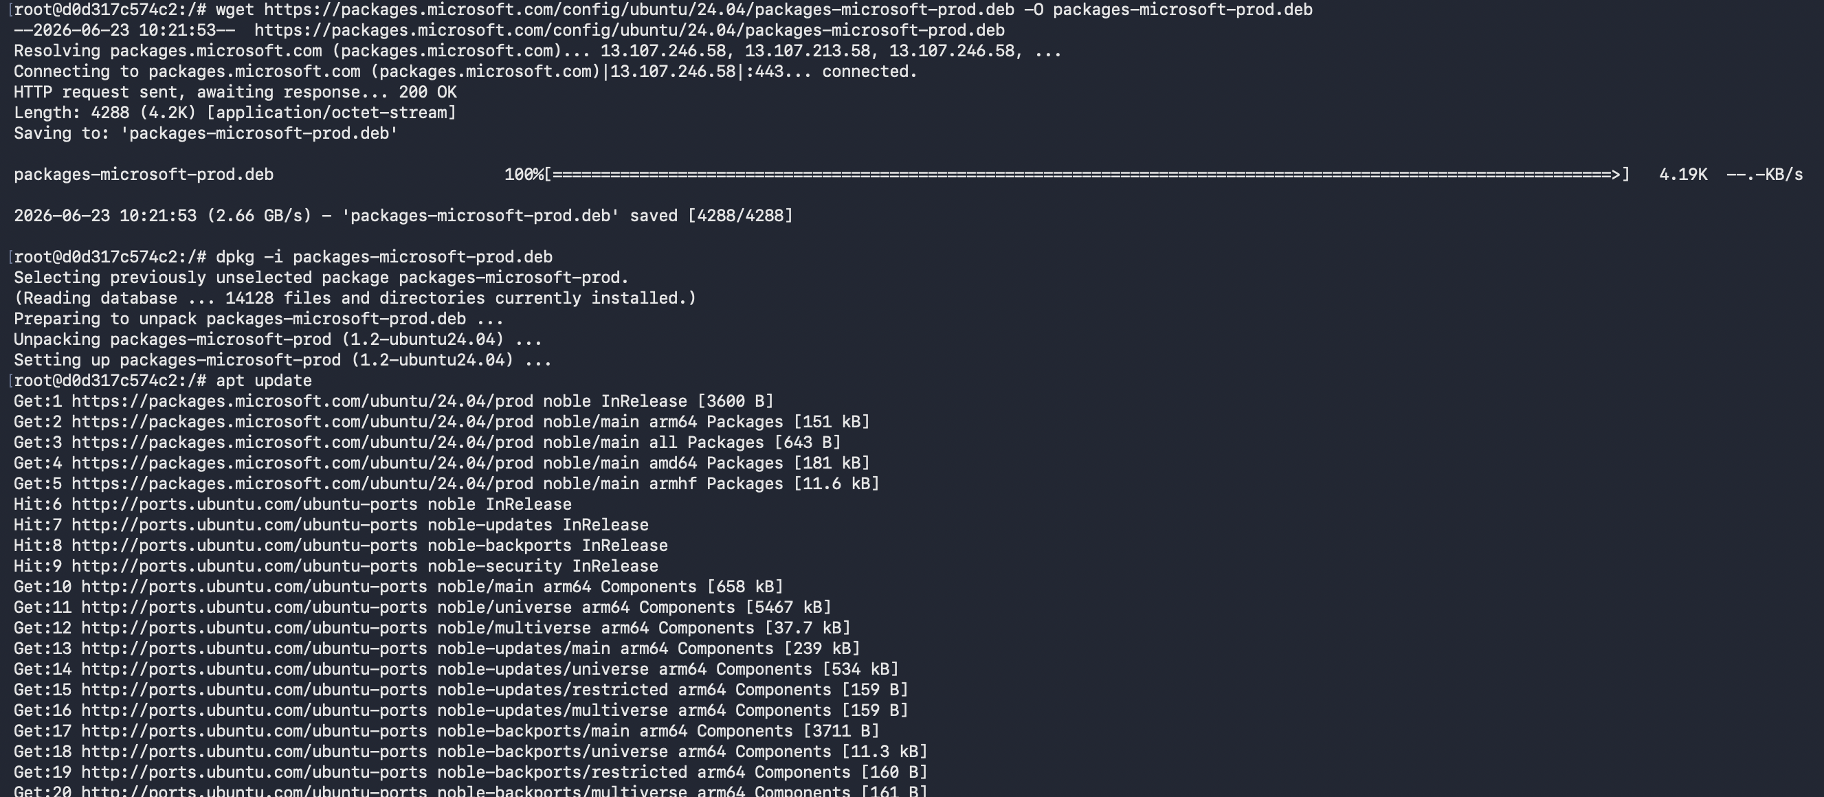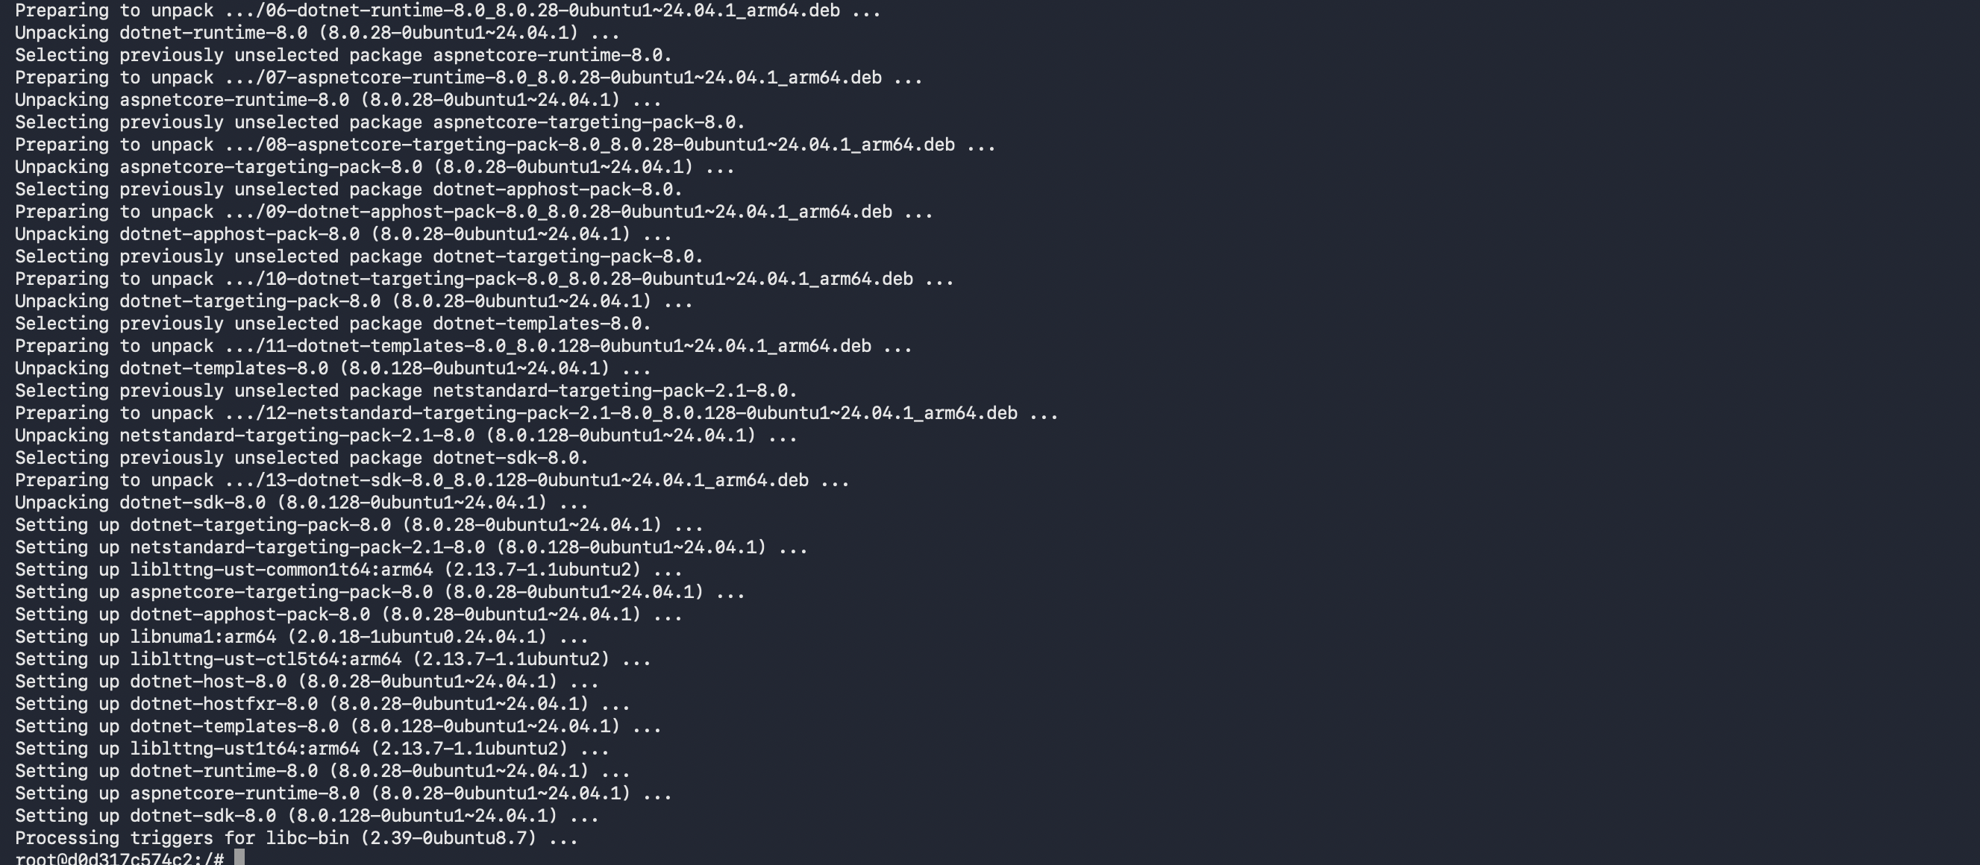
Student Notes: installed successfully

Step 7: Verify .NET Installation
Objective: Check that .NET is installed correctly.
Commands:
dotnet --version
dotnet --info
Command Explanation:
- dotnet --version shows the installed SDK version.
- dotnet --info shows installed SDKs, runtimes, OS and architecture.
Expected Output / Result:
Expected output should show .NET 8.x SDK and Microsoft.AspNetCore.App 8.x runtime.
Verification:
Capture dotnet --info output.
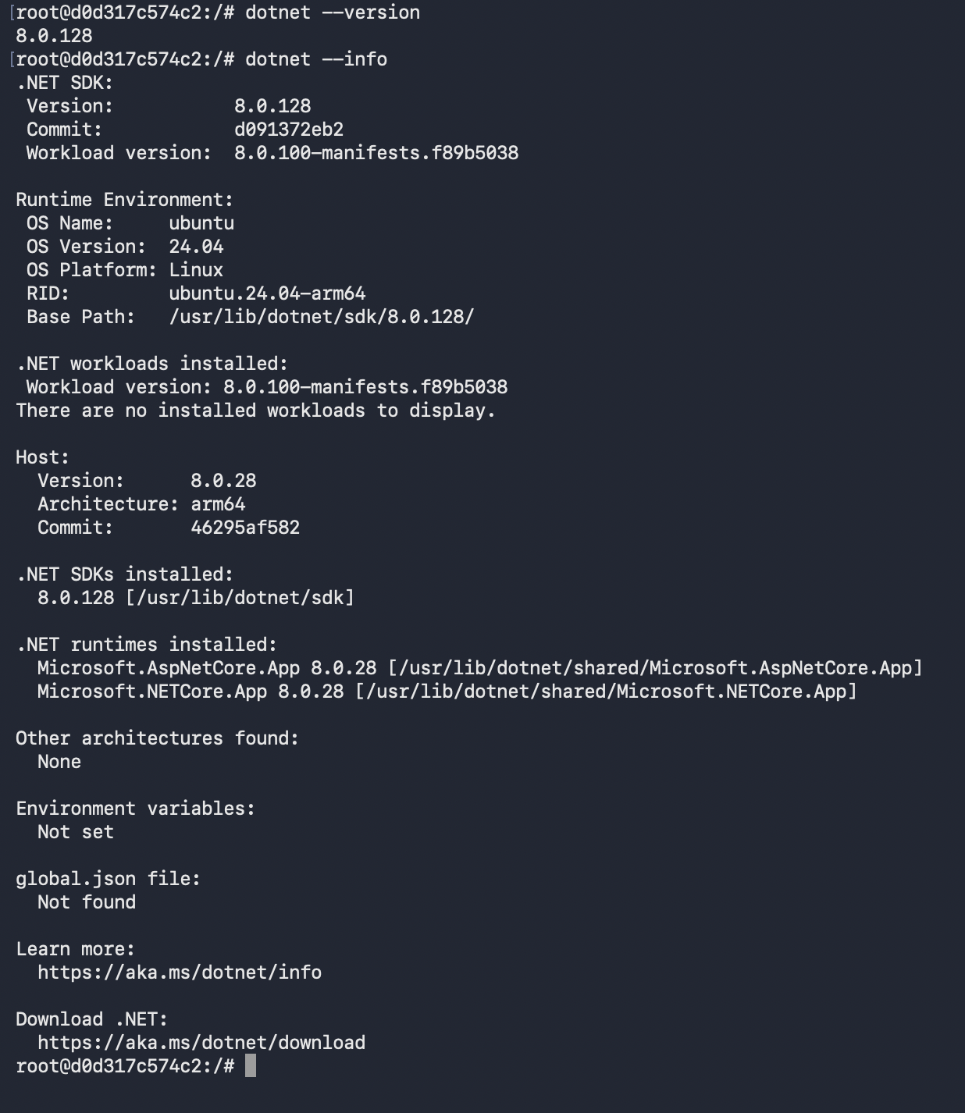
Student Notes: working fine

Step 8: Install Node.js and npm
Objective: Install Node.js and npm so the Angular project can be built.
Commands:
curl -fsSL https://deb.nodesource.com/setup_20.x | bash -
apt install -y nodejs
Command Explanation:
- NodeSource setup script adds the Node.js package repository.
- Node.js is required to run Angular build tools.
- npm is installed along with Node.js.
Expected Output / Result:
Node.js and npm should be installed.
Verification:
Run node -v and npm -v.
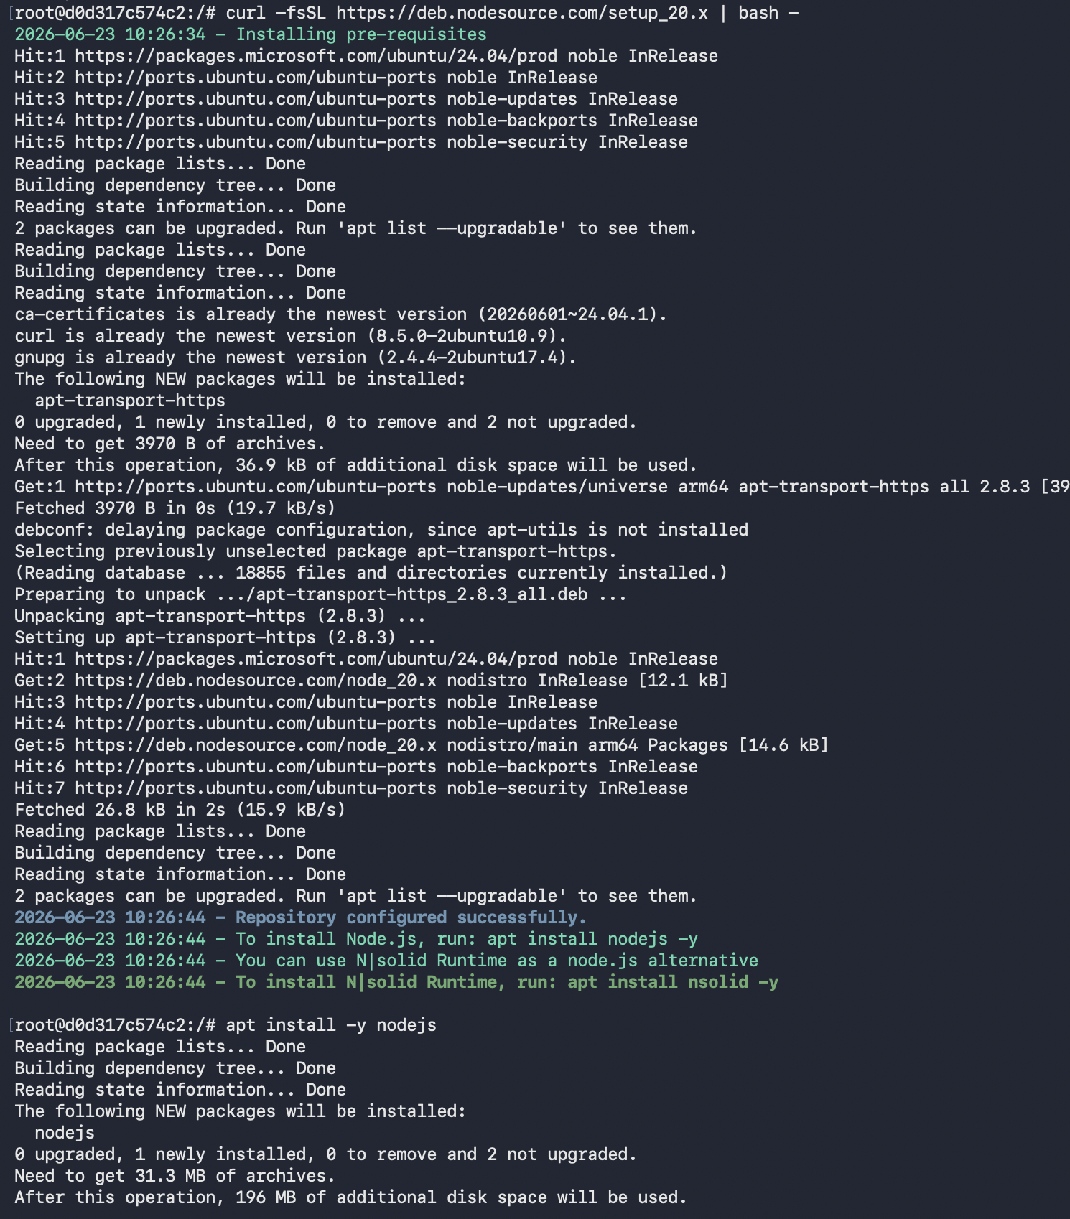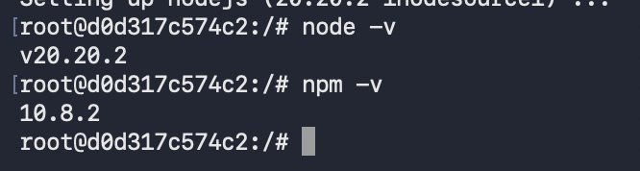
Student Notes: installed

Step 9: Verify Node.js and npm
Objective: Confirm Node.js and npm versions.
Commands:
node -v
npm -v
Command Explanation:
- node -v displays Node.js version.
- npm -v displays npm version.
Expected Output / Result:
Expected Node.js version should be v20.x or compatible with your Angular project.
Verification:
Capture both command outputs.

Student Notes: installed

Step 10: Install Angular CLI
Objective: Install Angular command line tool globally.
Commands:
npm install -g @angular/cli
ng version
Command Explanation:
- npm install -g installs a package globally inside the container.
- @angular/cli provides the ng command.
- ng version verifies Angular CLI installation.
Expected Output / Result:
Expected output shows Angular CLI version.
Verification:
Capture ng version output.
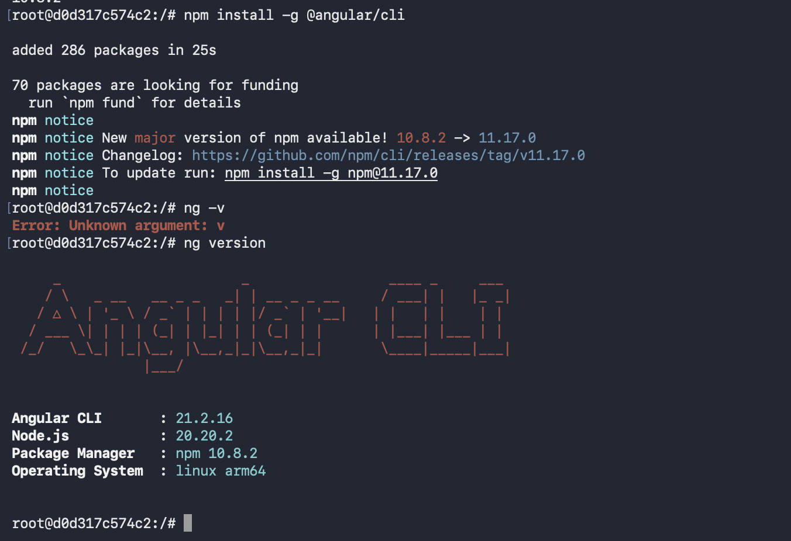
Student Notes: installed angular cli

Step 11: Install Nginx
Objective: Install Nginx web server inside Ubuntu container.
Commands:
apt install -y nginx
nginx -v
Command Explanation:
- Nginx will serve the Angular static files.
- Nginx will also forward API requests to the .NET backend.
- nginx -v displays the Nginx version.
Expected Output / Result:
Expected output: nginx version: nginx/x.x.x
Verification:
Capture nginx -v output.
Student Notes: installed

Step 12: Create Workspace Folder
Objective: Create a clean folder where both projects will be cloned.
Commands:
mkdir -p /workspace
cd /workspace
pwd
Command Explanation:
- mkdir -p creates the folder if it does not already exist.
- cd /workspace moves into the working folder.
- pwd confirms the current folder.
Expected Output / Result:
Expected output: /workspace
Verification:
Capture pwd output showing /workspace.
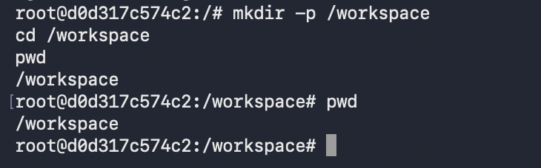
Student Notes: created workspace folder

Step 13: Clone .NET API Repository
Objective: Pull the backend source code from GitHub.
Commands:
cd /workspace
git clone https://github.com/114-Vaibhav/demo-dotnet-api.git
ls
Command Explanation:
- Replace <DOTNET_API_REPO_URL> with the real GitHub URL.
- git clone downloads the repository into a local folder.
- ls lists the cloned folder.
Expected Output / Result:
You should see the backend repository folder.
Verification:
Capture git clone success output and ls output.
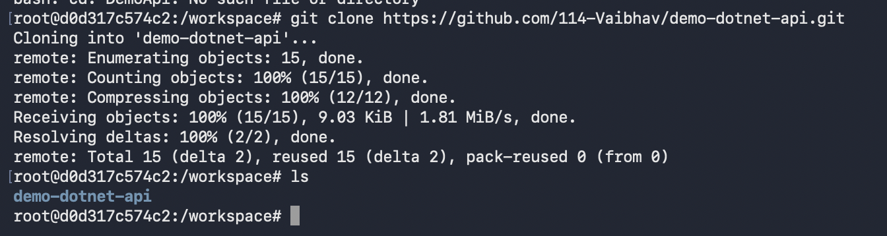
Student Notes: created and cloned dotnet demo

Step 14: Restore and Build .NET API
Objective: Download NuGet packages and build the backend application.
Commands:
cd /workspace/ demo-dotnet-api
dotnet restore
dotnet build
Command Explanation:
- dotnet restore downloads NuGet dependencies.
- dotnet build compiles the application.
- Replace <DOTNET_API_FOLDER_NAME> with the actual cloned folder name.
Expected Output / Result:
Expected output: Build succeeded.
Verification:
Capture Build succeeded output.
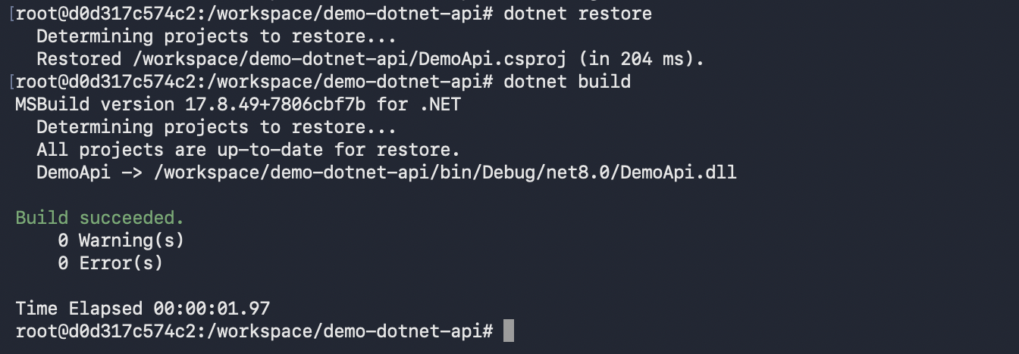
Student Notes: there was some issue of dotnet version after clone, build successful

Step 15: Run .NET API for Initial Test
Objective: Start the backend API inside the container.
Commands:
cd /workspace/<DOTNET_API_FOLDER_NAME>
ASPNETCORE_URLS=http://0.0.0.0:5000 dotnet run
Command Explanation:
- ASPNETCORE_URLS tells the API to listen on all network interfaces.
- http://0.0.0.0:5000 makes it accessible through Docker port mapping.
- dotnet run starts the application from source code.
Expected Output / Result:
Expected output includes Now listening on: http://0.0.0.0:5000.
Verification:
From the host browser, try http://localhost:5000 or http://localhost:5000/swagger if Swagger exists. Stop the API with Ctrl+C after testing.
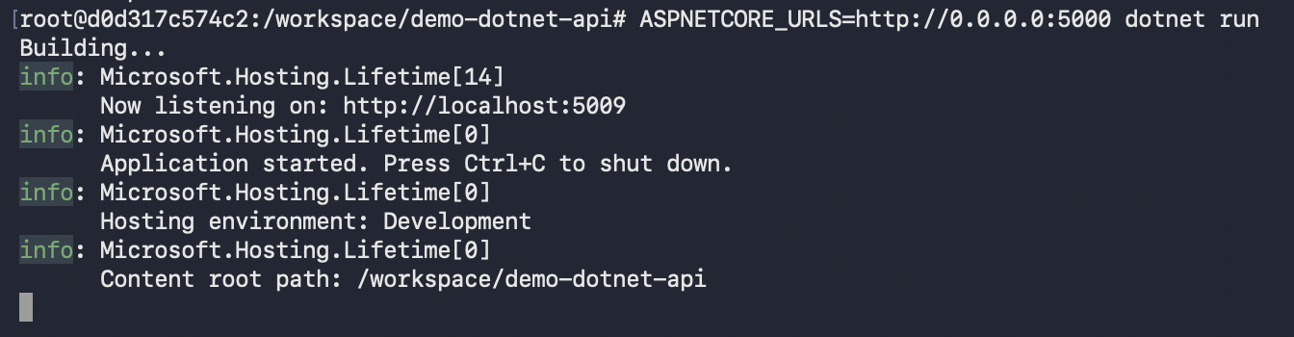
Student Notes: running on 5009

Step 16: Publish .NET API
Objective: Create a production-ready published output folder.
Commands:
cd /workspace/<DOTNET_API_FOLDER_NAME>
dotnet publish -c Release -o /app/api
Command Explanation:
- dotnet publish prepares compiled files for deployment.
- -c Release creates a release build.
- -o /app/api places the published output in /app/api.
Expected Output / Result:
Expected output says the project was published to /app/api.
Verification:
Run ls /app/api and capture the files.
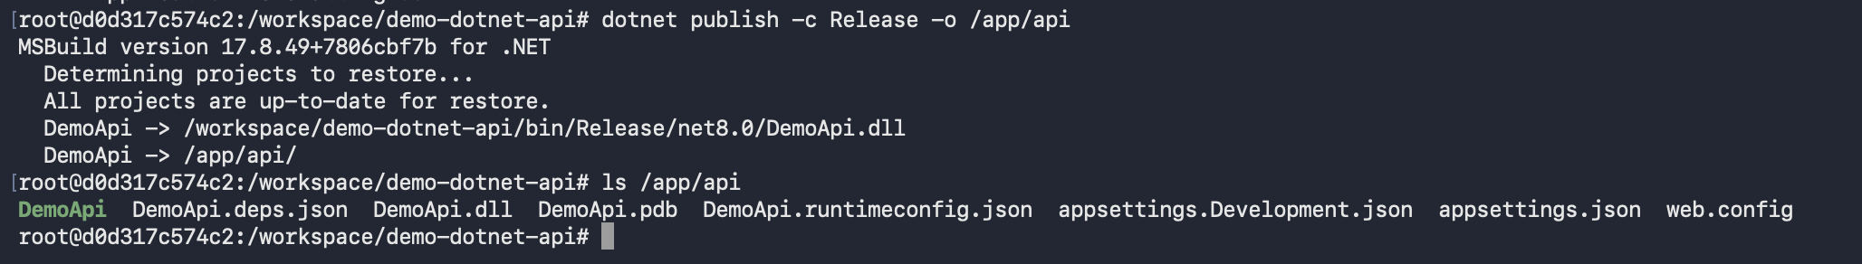

Step 17: Run Published API in Background
Objective: Run the published API as a background process so Nginx can proxy to it.
Commands:
cd /app/api
ASPNETCORE_URLS=http://127.0.0.1:5000 nohup dotnet DemoApi.dll > /var/log/dotnet-api.log 2>&1 &
ps -ef | grep dotnet
cat /var/log/dotnet-api.log
Command Explanation:
- nohup allows the process to continue running after the shell returns.
- & starts the process in the background.
- 127.0.0.1:5000 means the API listens locally inside the container.
- <DOTNET_PROJECT_FILE_NAME>.dll must be replaced with your actual DLL name.
- The log file helps troubleshoot startup errors.
Expected Output / Result:
Expected: ps output should show a dotnet process. The log should show the API started successfully.
Verification:
Capture ps -ef and log output.
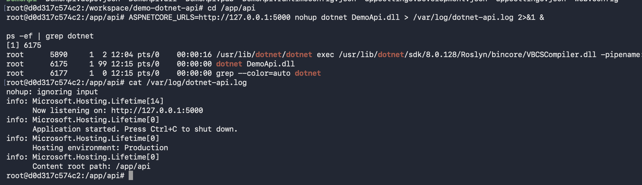
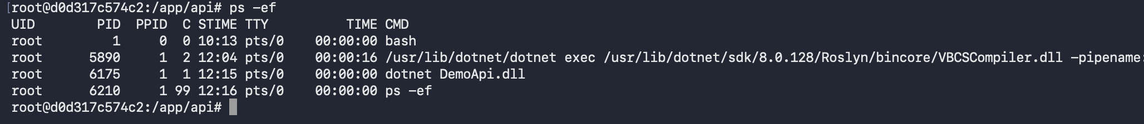
Student Notes: running in background

Step 18: Clone Angular Repository
Objective: Pull the Angular frontend source code from GitHub.
Commands:
cd /workspace
git clone https://github.com/114-Vaibhav/demo-angular-app.git
ls
Command Explanation:
- Replace <ANGULAR_REPO_URL> with your real Angular GitHub repository URL.
- The repository will be downloaded into /workspace.
- ls confirms the folder exists.
Expected Output / Result:
You should see the Angular project folder.
Verification:
Capture git clone success output.
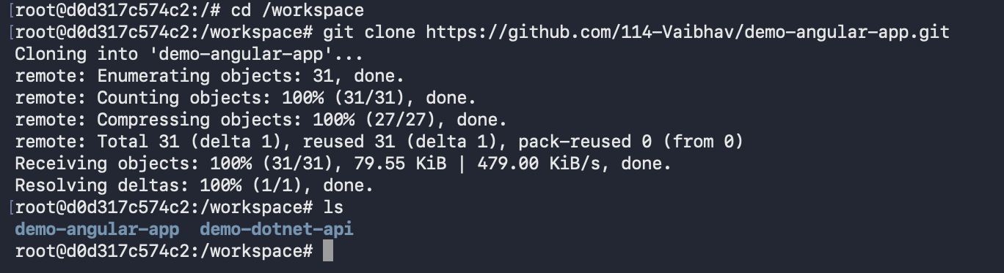
Student Notes: cloned

Step 19: Install Angular Dependencies
Objective: Install packages required by the Angular project.
Commands:
cd /workspace/<ANGULAR_FOLDER_NAME>
npm install
Command Explanation:
- npm install reads package.json.
- It downloads project dependencies into node_modules.
- This may take a few minutes.
Expected Output / Result:
Expected output should complete without fatal errors.
Verification:
Capture the final npm install success output.
Screenshot Placeholder
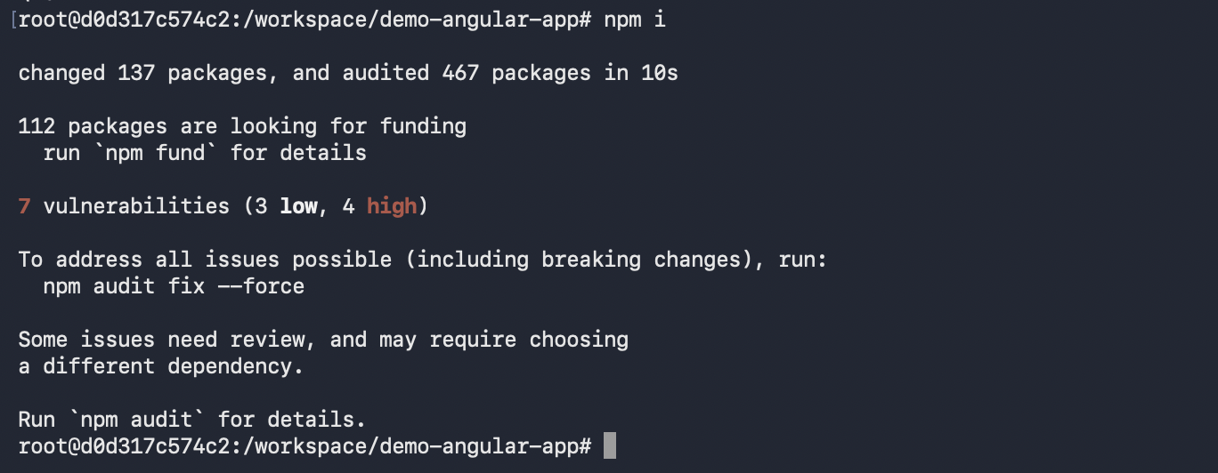
Student Notes: node_modules installed

Step 20: Configure Angular API URL Placeholder
Objective: Update Angular configuration so API calls go through Nginx /api path.
Commands:
# Open your Angular environment file if your project uses one
nano src/environments/environment.ts
# Example value to use inside Angular
# apiBaseUrl: "/api"
Command Explanation:
- This step depends on your Angular project structure.
- The recommended browser-facing API URL is /api.
- Using /api allows Nginx to forward calls to the backend API running on port 5000 inside the container.
- If your app uses a different config file, update that file instead.
Expected Output / Result:
Angular source should point API calls to /api or relative API paths.
Verification:
Capture the updated environment/configuration file.
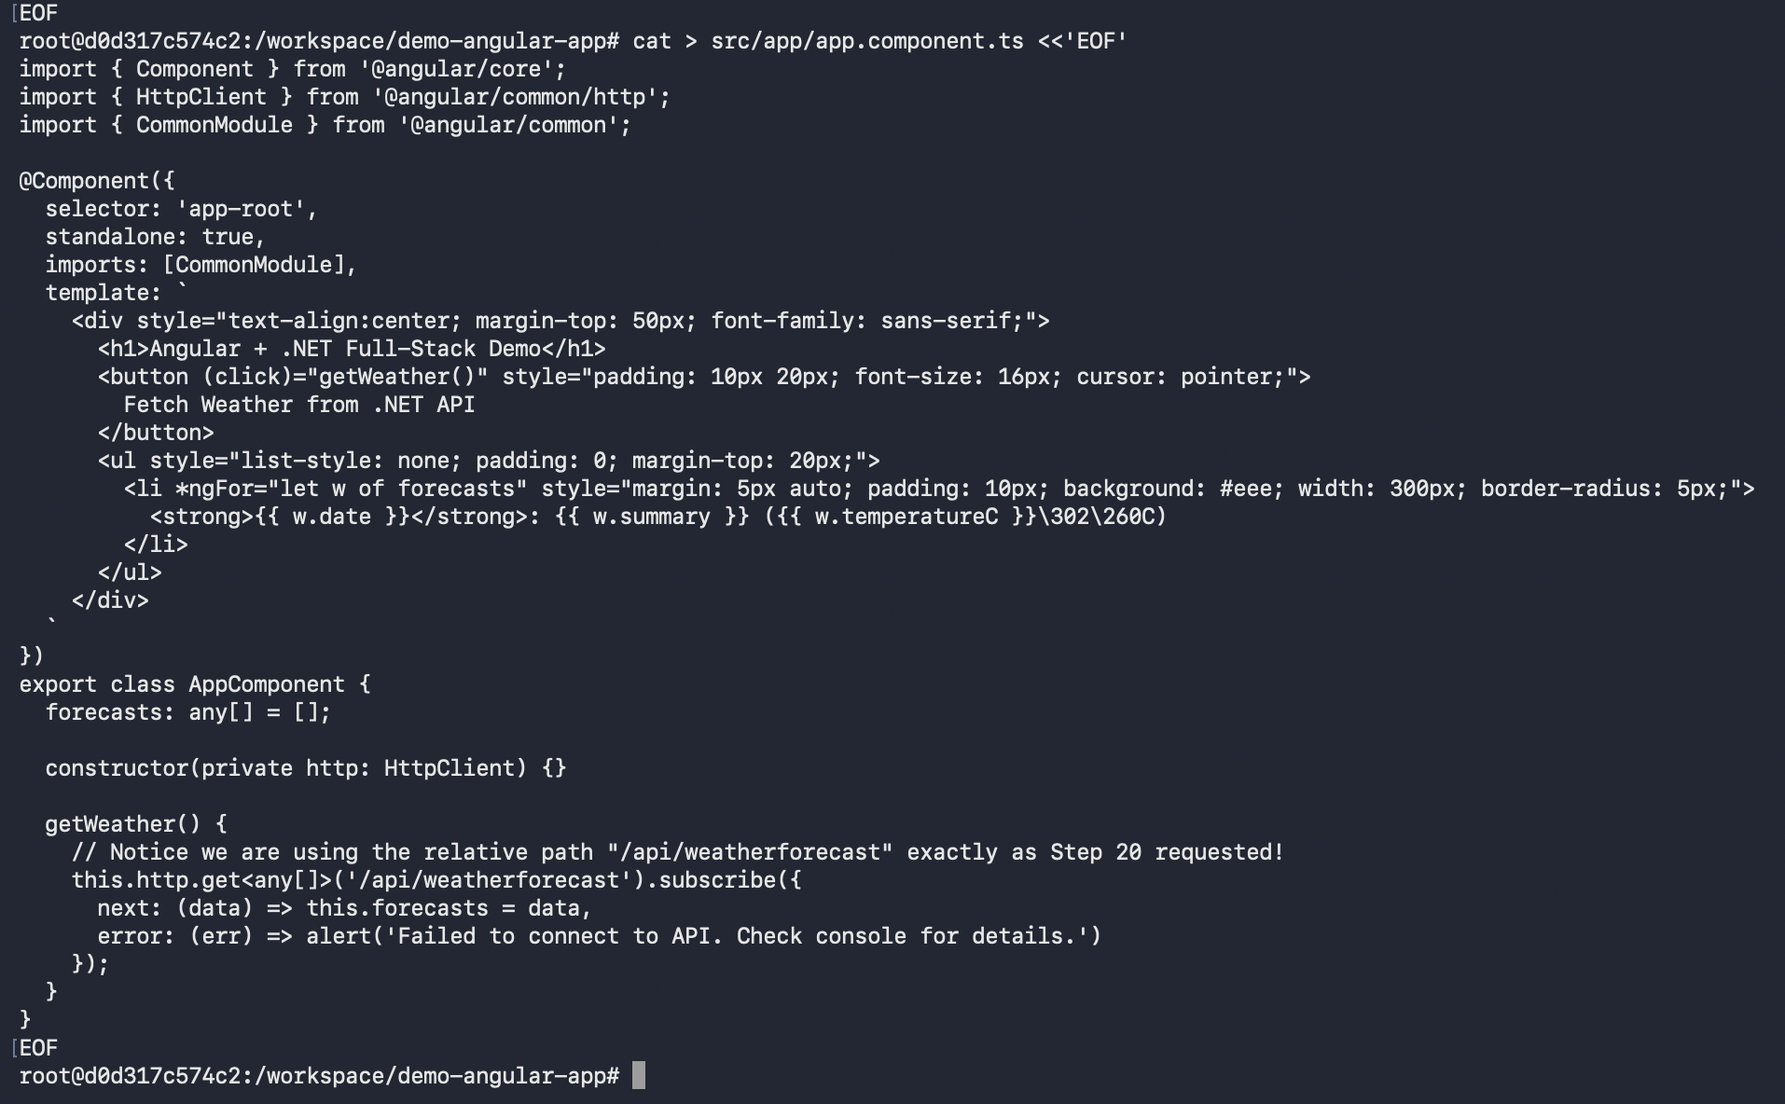

Step 21: Build Angular Application
Objective: Build Angular static files for production.
Commands:
cd /workspace/<ANGULAR_FOLDER_NAME>
ng build --configuration production
Command Explanation:
- ng build compiles the Angular app.
- --configuration production creates optimized static files.
- The output usually goes into dist/<project-name>.
Expected Output / Result:
Expected output: build completed successfully and dist folder created.
Verification:
Run ls dist and capture the output.
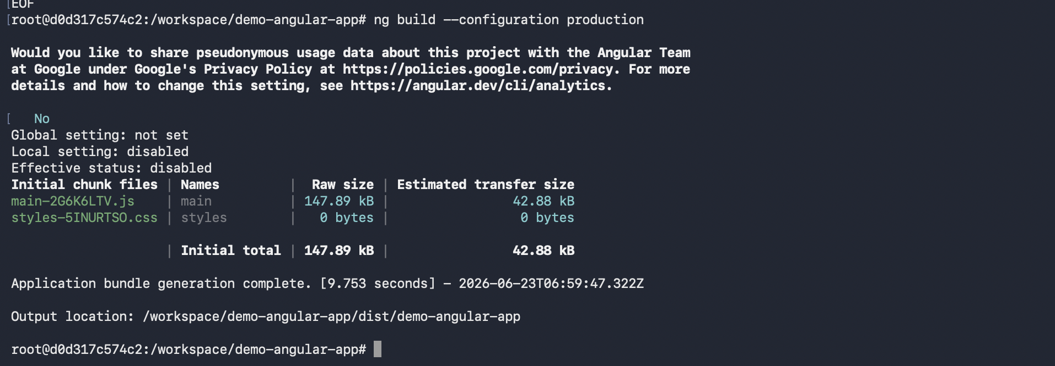
Student Notes: build successful

Step 22: Deploy Angular Build to Nginx Web Root
Objective: Copy the Angular build output into the Nginx hosting folder.
Commands:
rm -rf /var/www/html/*
mkdir -p /var/www/html/angular
cp -r /workspace/demo-angular-app/dist/demo-angular-app/* /var/www/html/angular/
ls -la /var/www/html/angular
Command Explanation:
- rm -rf clears default Nginx files.
- mkdir creates the folder that will host Angular files.
- cp copies built Angular files into Nginx web root.
- <ANGULAR_DIST_FOLDER_NAME> must match the actual folder inside dist.
Expected Output / Result:
Expected output should include index.html and static JavaScript/CSS files.
Verification:
Capture ls -la /var/www/html/angular output.
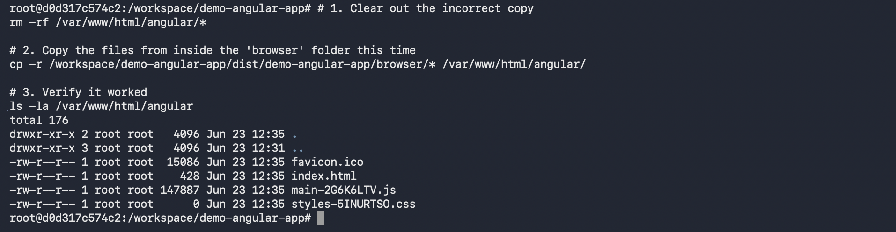

Step 23: Create Nginx Configuration for Angular and API Reverse Proxy
Objective: Configure Nginx to serve Angular and forward API requests to the .NET backend.
Commands:
cat > /etc/nginx/sites-available/default <<'EOF'
server {
listen 80;
server_name _;
root /var/www/html/angular;
index index.html;
location / {
try_files $uri $uri/ /index.html;
}
location /api/ {
proxy_pass http://127.0.0.1:5000/;
proxy_http_version 1.1;
proxy_set_header Host $host;
proxy_set_header X-Real-IP $remote_addr;
proxy_set_header X-Forwarded-For $proxy_add_x_forwarded_for;
proxy_set_header X-Forwarded-Proto $scheme;
}
}
EOF
nginx -t
Command Explanation:
- listen 80 tells Nginx to listen on port 80 inside the container.
- root points to Angular build files.
- try_files supports Angular client-side routing.
- location /api forwards API requests to the .NET app on port 5000.
- nginx -t validates the configuration syntax.
Expected Output / Result:
Expected output: syntax is ok and test is successful.
Verification:
Capture nginx -t output.
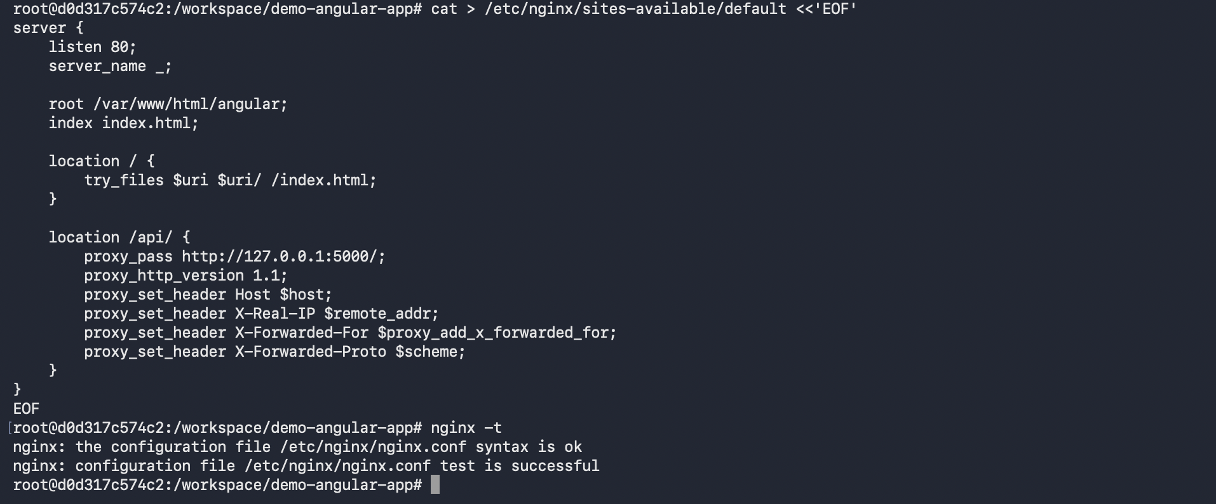

Step 24: Start or Reload Nginx
Objective: Start Nginx so the Angular app becomes available.
Commands:
nginx
# If Nginx is already running, use this instead:
nginx -s reload
ps -ef | grep nginx
Command Explanation:
- nginx starts the web server.
- nginx -s reload reloads configuration without stopping Nginx.
- ps -ef confirms that Nginx master and worker processes are running.
Expected Output / Result:
Expected output should show nginx master process and worker process.
Verification:
Capture ps -ef | grep nginx output.
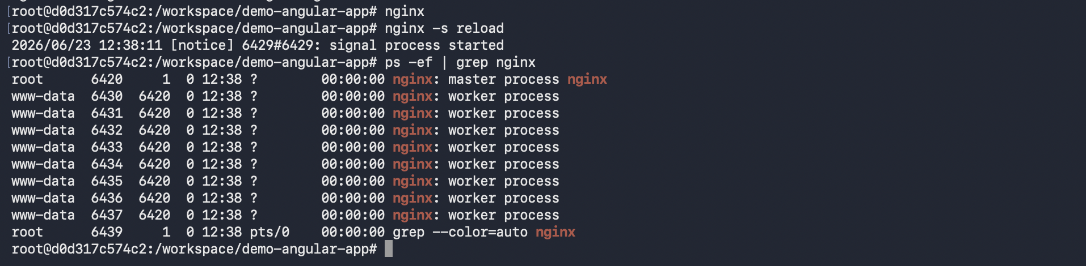

Step 25: Test from Inside the Container
Objective: Verify Angular and API proxy from inside Ubuntu first.
Commands:
curl http://localhost
curl http://localhost/api/health
# If your API does not have /health, test another endpoint:
# curl http://localhost/api/<your-api-endpoint>
Command Explanation:
- curl http://localhost checks Angular/Nginx.
- curl http://localhost/api/health checks whether Nginx can reach the .NET API.
- If your API does not have /health, use an endpoint from your backend project.
Expected Output / Result:
Angular curl may return HTML. API curl should return API response.
Verification:
Capture both curl outputs.
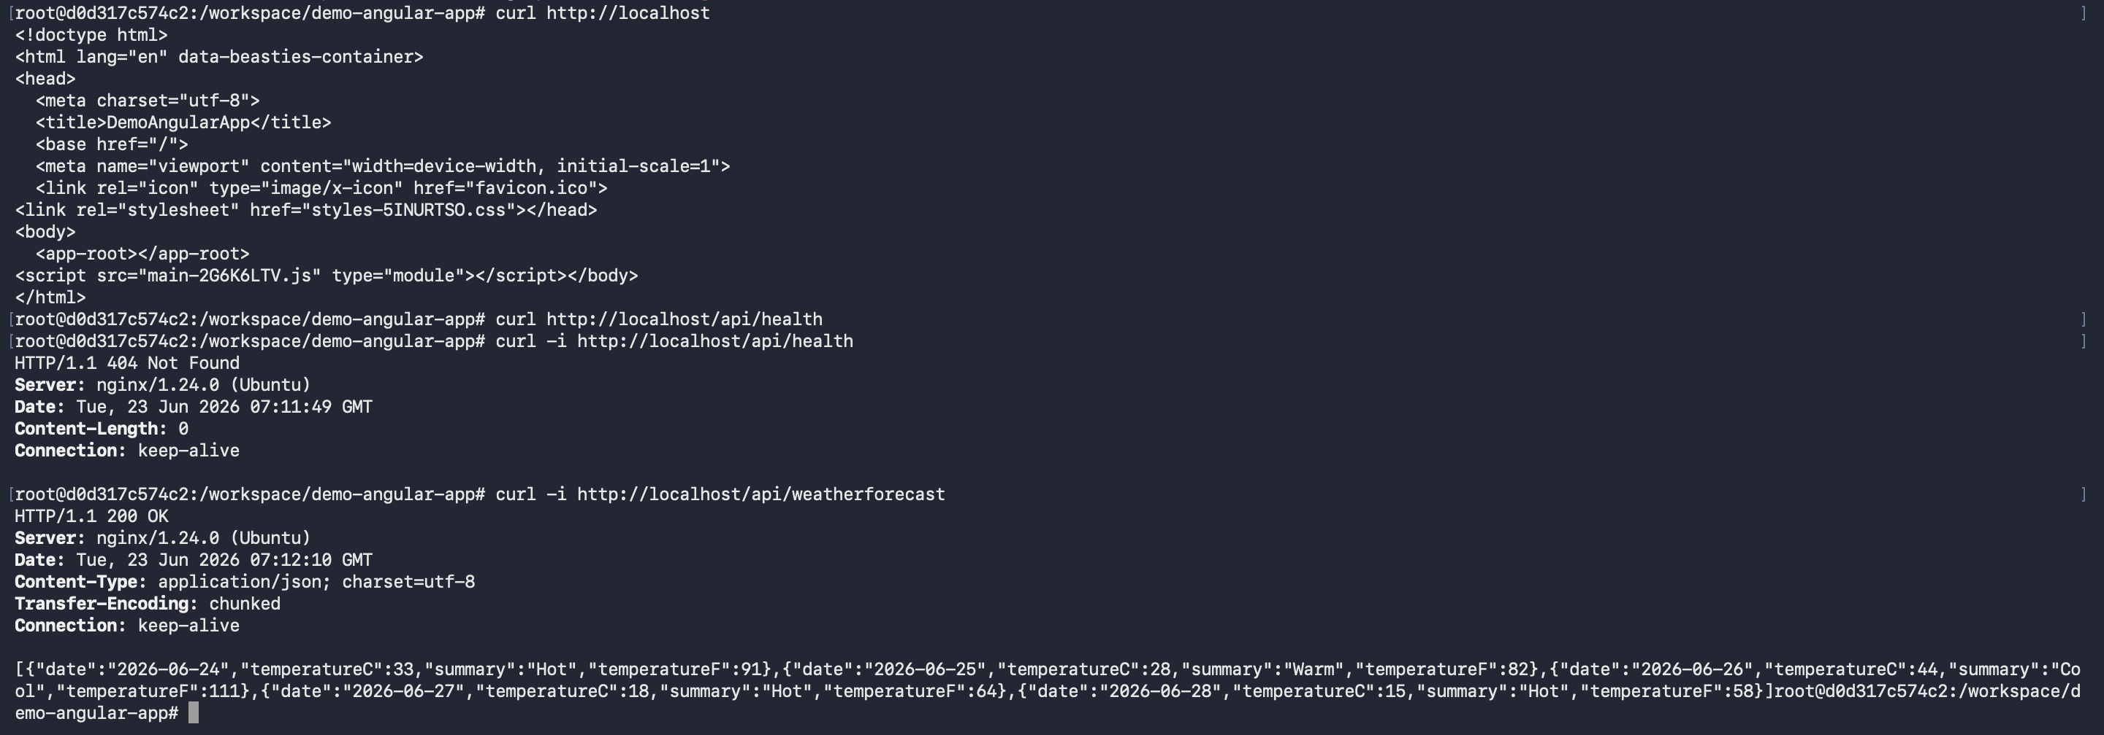

Step 26: Test from Local Host Browser
Objective: Access the Angular app from the Windows browser.
Commands:
Open browser on the host machine:
http://localhost:8080
Optional direct API test:
http://localhost:8080/api/health
Command Explanation:
- Docker maps host port 8080 to container port 80.
- The browser talks to Nginx.
- Nginx serves Angular and proxies API calls.
Expected Output / Result:
Expected: Angular app opens in browser. API requests from Angular should reach the .NET backend.
Verification:
Capture browser screenshot showing Angular loaded from localhost:8080.
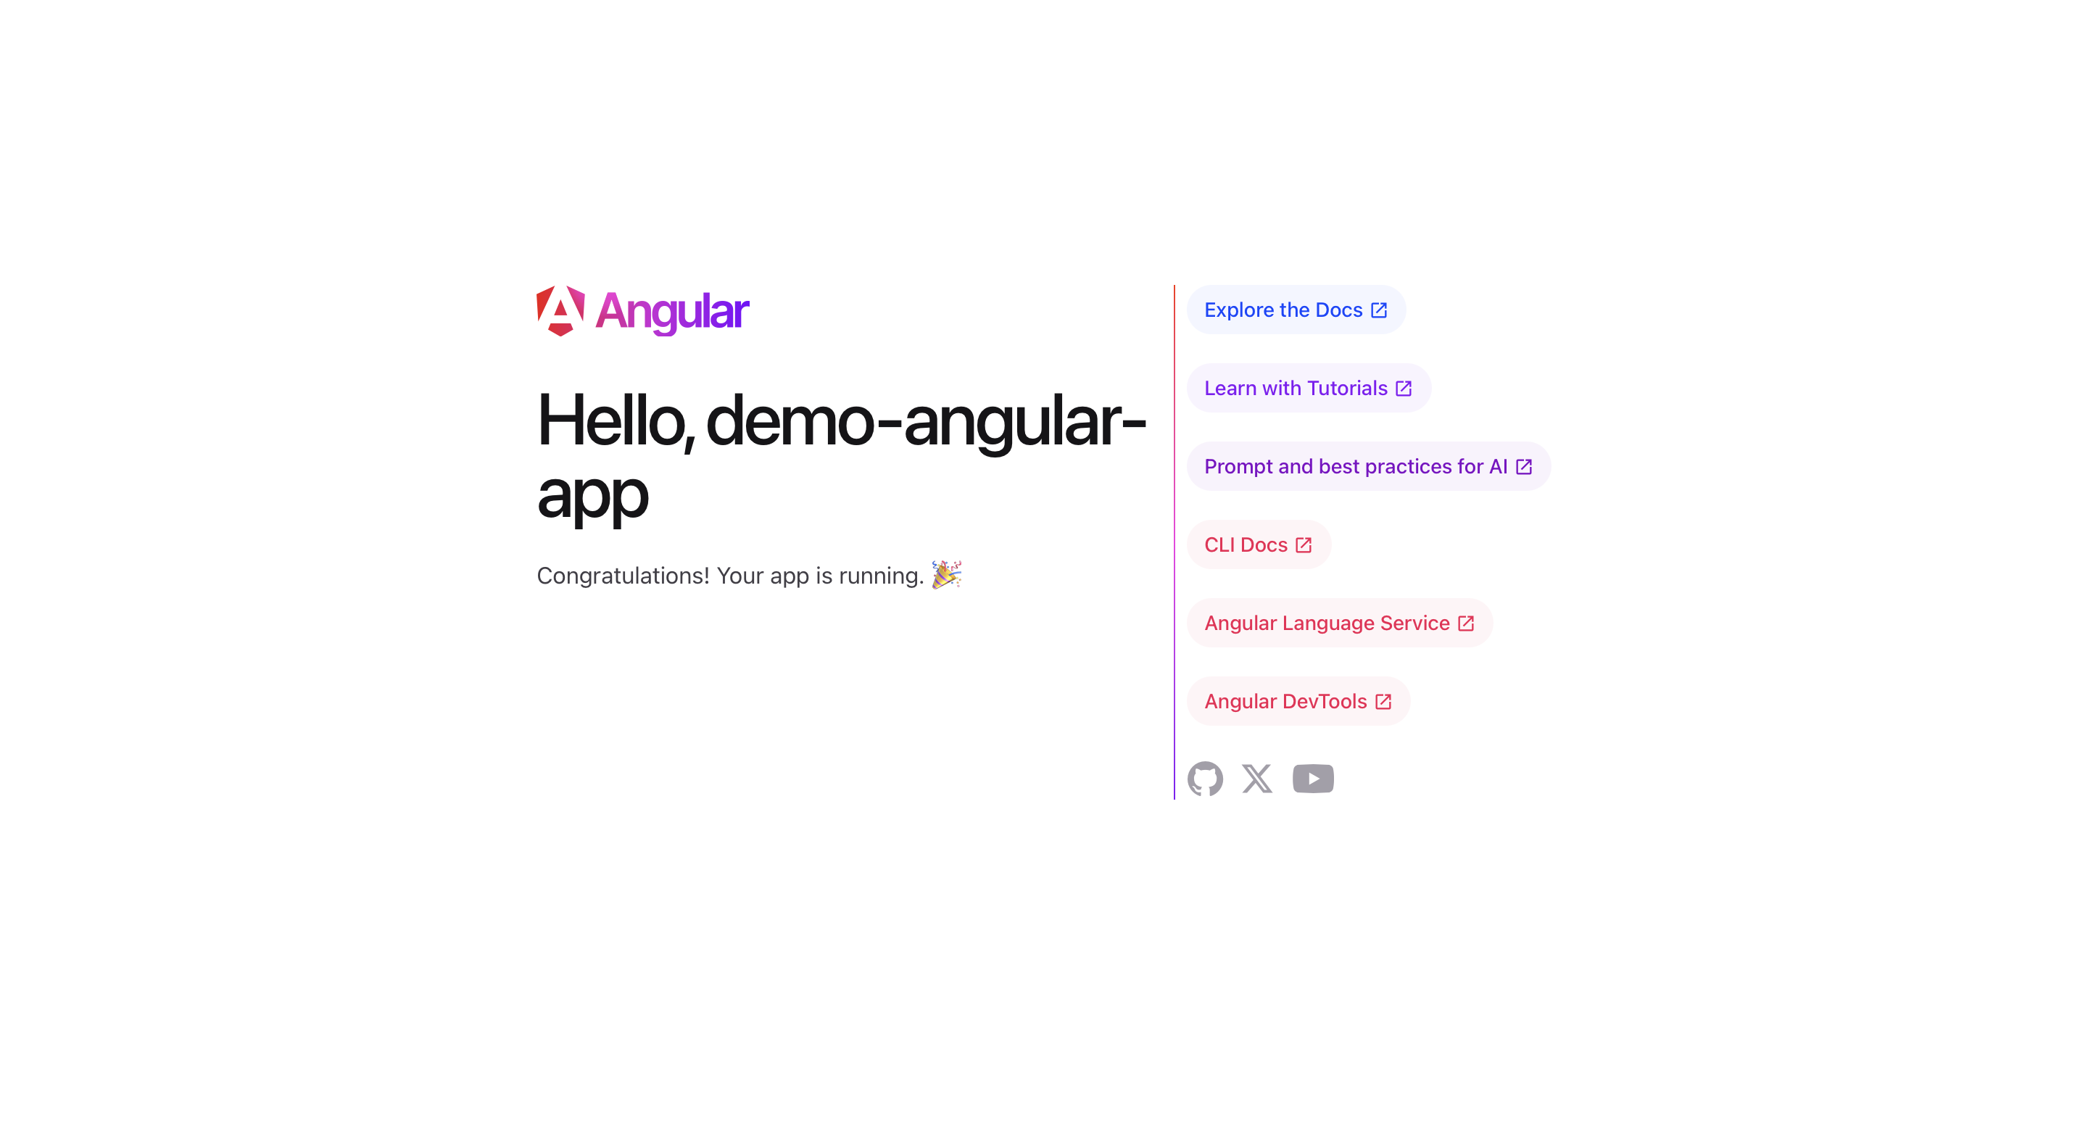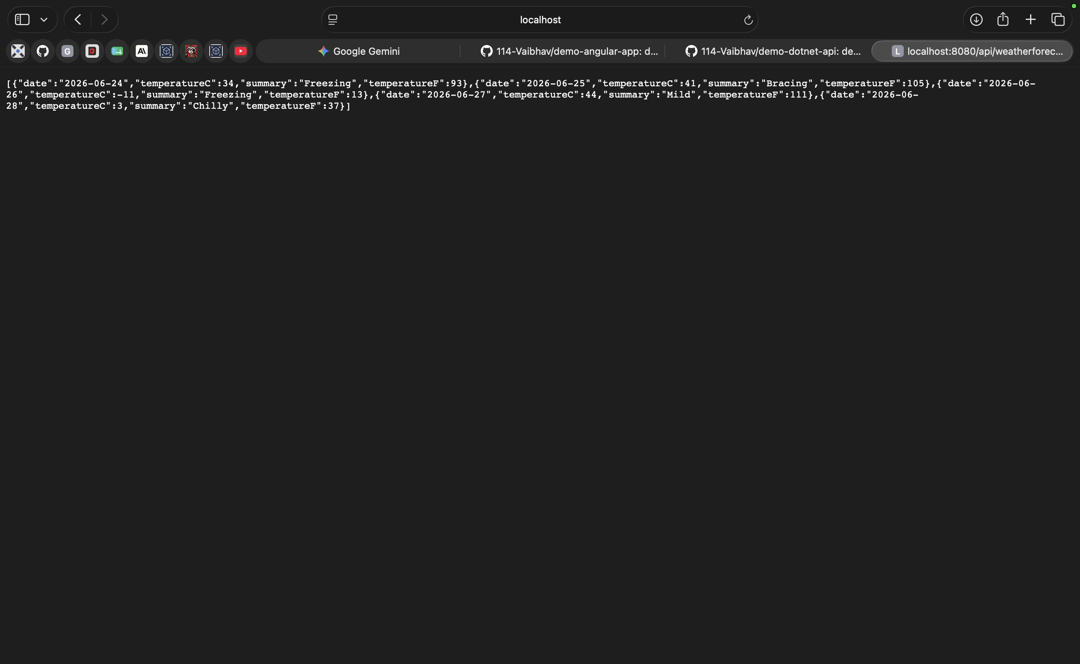

Step 27: Check Logs for Troubleshooting
Objective: Use logs to diagnose application or Nginx errors.
Commands:
cat /var/log/dotnet-api.log
tail -n 50 /var/log/nginx/access.log
tail -n 50 /var/log/nginx/error.log
Command Explanation:
- dotnet-api.log shows backend startup/runtime logs.
- Nginx access log shows browser/API requests.
- Nginx error log shows configuration and proxy errors.
Expected Output / Result:
Expected: no fatal errors in logs.
Verification:
Capture logs if troubleshooting is required.
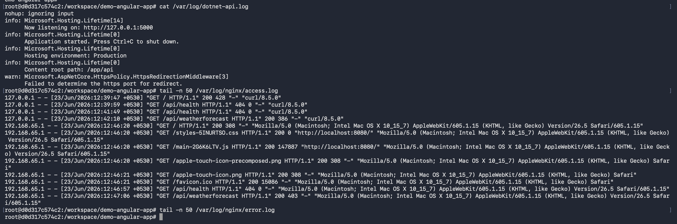

Step 28: Stop and Restart Existing Container
Objective: Learn how to leave and return to the container without losing installed tools.
Commands:
# Inside container
exit
# On host machine
docker ps -a
docker start fullstack-ubuntu
docker exec -it fullstack-ubuntu bash
Command Explanation:
- exit leaves the container shell.
- docker ps -a shows stopped and running containers.
- docker start restarts the existing container.
- docker exec opens a new shell inside the running container.
Expected Output / Result:
You should return to the Ubuntu shell with installed tools still available.
Verification:
Capture docker ps -a and shell prompt after docker exec.
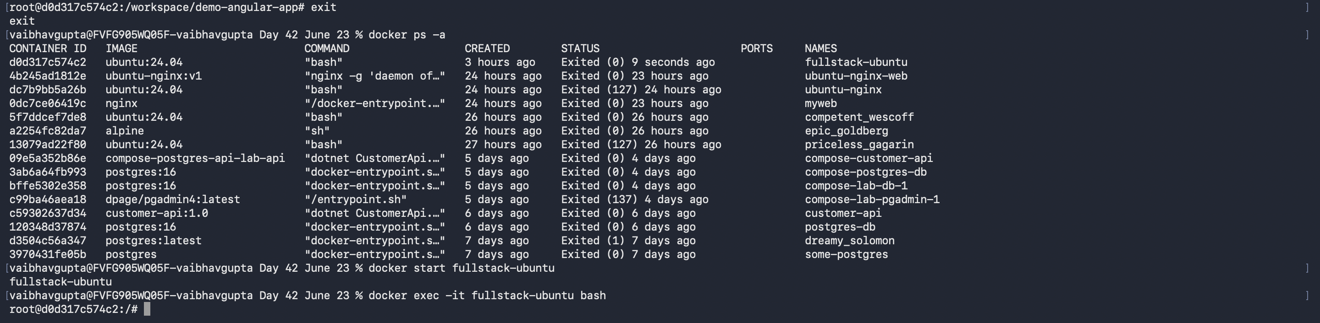

Step 29: Optional: Save the Configured Container as an Image
Objective: Convert the configured container into a reusable image for later labs.
Commands:
# Run this on host machine after exiting the container if needed
docker commit fullstack-ubuntu fullstack-ubuntu-web:v1
docker images
Command Explanation:
- docker commit saves the current container state as an image.
- This is useful for training demos.
- In production, a Dockerfile is preferred.
Expected Output / Result:
Expected: image fullstack-ubuntu-web:v1 appears in docker images.
Verification:
Capture docker images output.
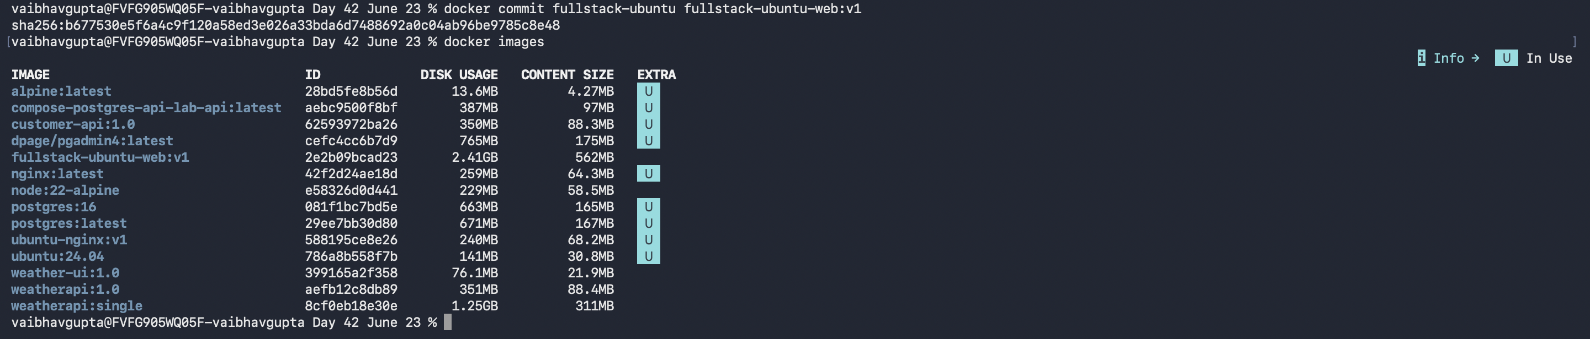

Step 30: Cleanup Lab Resources
Objective: Remove the lab container when finished.
Commands:
docker stop fullstack-ubuntu
docker rm fullstack-ubuntu
# Optional: remove saved image
# docker rmi fullstack-ubuntu-web:v1
Command Explanation:
- docker stop stops the container.
- docker rm removes the container.
- docker rmi removes the saved image if created.
Expected Output / Result:
Container should be removed successfully.
Verification:
Capture docker ps -a output after removal.

Troubleshooting Guide
Problem | Fix
Port 8080 already in use | Use a different host port, for example -p 8090:80, then open http://localhost:8090.
dotnet command not found | Check whether .NET installation completed. Run apt update and reinstall dotnet-sdk-8.0.
ng command not found | Angular CLI may not be installed globally. Run npm install -g @angular/cli.
Angular build fails | Run npm install again. Check Node.js version compatibility. Read the error message carefully.
Nginx configuration test fails | Run nginx -t and fix the exact line mentioned in the error.
API works directly on port 5000 but not through /api | Check proxy_pass configuration and verify the API process is running on 127.0.0.1:5000.
Browser shows Nginx default page | Make sure Angular files are copied to /var/www/html/angular and root points to that folder.
Angular refresh shows 404 | Make sure try_files $uri $uri/ /index.html; is present in the Nginx location / block.

Final Lab Checklist
☐ Ubuntu container started with port mapping 8080:80 and 5000:5000. ✅
☐ Git installed and verified. ✅
☐ .NET SDK/runtime installed and verified. ✅
☐ Node.js and npm installed and verified. ✅
☐ Angular CLI installed and verified. ✅
☐ Nginx installed and verified. ✅
☐ .NET API repository cloned from GitHub. ✅
☐ .NET API restored, built, published, and running. ✅
☐ Angular repository cloned from GitHub. ✅
☐ Angular dependencies installed and production build completed. ✅
☐ Angular files copied to Nginx root folder. ✅
☐ Nginx reverse proxy configured for /api. ✅
☐ Angular app accessible from host browser at http://localhost:8080. ✅
☐ Angular can call backend API through Nginx proxy. ✅

Knowledge Check Questions
- Why do we map host port 8080 to container port 80?
Answer: So we can view the container's website from our own computer's browser.
- What is the purpose of Git in this lab?
Answer: _to download the projects code from the internet ________________________________________________________________
- Why do we install .NET SDK instead of only .NET runtime?
Answer: because we need the sdk to build the code not just run it. _________________________________________________________________
- What does npm install do?
Answer: it downloads all extra packages, store them in node_modules _________________________________________________________________
- What does ng build --configuration production create?
Answer: it builds the final, ready to use website _________________________________________________________________
- Why does Angular need Nginx after build?
Answer: angular only creates the files, Nginx is the server needed to show them on internet _________________________________________________________________
- What is the role of proxy_pass in Nginx?
Answer: it takes specific web requests and sends them to the backend api _________________________________________________________________
- Why do we use /api as the backend path?
Answer: to help Nginx easily tell the difference b/w website pages and backend api requests _________________________________________________________________
- What is the purpose of nohup when running the .NET API?
Answer: it keeps the api running in the background even if we close the command window _________________________________________________________________
- Why is Dockerfile preferred over docker commit in real projects?
Answer: it is easy ti share and reuse, while commit is manual save. _________________________________________________________________

Appendix A: Placeholder Replacement Guide
<DOTNET_API_REPO_URL> Example: https://github.com/your-org/your-api.git
<DOTNET_API_FOLDER_NAME> Example: your-api
<DOTNET_PROJECT_FILE_NAME> Example: YourApi
<ANGULAR_REPO_URL> Example: https://github.com/your-org/your-angular-app.git
<ANGULAR_FOLDER_NAME> Example: your-angular-app
<ANGULAR_DIST_FOLDER_NAME> Example: your-angular-app or browser depending on Angular version

Appendix B: Full Command Summary
docker pull ubuntu:24.04
docker run -it --name fullstack-ubuntu -p 8080:80 -p 5000:5000 ubuntu:24.04 bash
apt update
apt install -y git curl wget nano ca-certificates gnupg lsb-release software-properties-common
wget https://packages.microsoft.com/config/ubuntu/24.04/packages-microsoft-prod.deb -O packages-microsoft-prod.deb
dpkg -i packages-microsoft-prod.deb
apt update
apt install -y dotnet-sdk-8.0 aspnetcore-runtime-8.0
curl -fsSL https://deb.nodesource.com/setup_20.x | bash -
apt install -y nodejs
npm install -g @angular/cli
apt install -y nginx
mkdir -p /workspace
cd /workspace
git clone <DOTNET_API_REPO_URL>
cd /workspace/<DOTNET_API_FOLDER_NAME>
dotnet restore
dotnet build
dotnet publish -c Release -o /app/api
cd /app/api
ASPNETCORE_URLS=http://127.0.0.1:5000 nohup dotnet <DOTNET_PROJECT_FILE_NAME>.dll > /var/log/dotnet-api.log 2>&1 &
cd /workspace
git clone <ANGULAR_REPO_URL>
cd /workspace/<ANGULAR_FOLDER_NAME>
npm install
ng build --configuration production
rm -rf /var/www/html/*
mkdir -p /var/www/html/angular
cp -r /workspace/<ANGULAR_FOLDER_NAME>/dist/<ANGULAR_DIST_FOLDER_NAME>/* /var/www/html/angular/
nginx -t
nginx
curl http://localhost
curl http://localhost/api/health
# Host browser
# http://localhost:8080

